**World Women Hackathon**

The occasion is about ladies strengthening WWH i.e, "[World Women Hackathon](http://www.asiabookofrecords.com/largest-women-hackathon/)" has been conceived to energize more ladies which will prompts numerous ladies into innovation. They sorted out the occasion for around two days by support of 2000+ ladies to assemble their own particular advanced portfolio site utilizing dynamic web applications. By leading such occasions each lady come to realize that the significance of the advanced innovation and the will think about their own particular dreams and make it as could be allowed. Seeing these kind of occasion can make atleast a portion of the ladies get empowered and be fruitful throughout everyday life.

All ladies have dreams some have of all shapes and sizes. Not about the thing is little or huge but rather the fantasy matters alot. Envisioning alone isn't sufficient for our general public, "if a young lady dreams our general public make her moronic" with their convention and ceremonies. They have some do's and don't. each young lady require her instruction without a doubt , Bt all things considered we ought to be strong and gather in our own fantasies. These days in every single work we have a ladies or young lady. There are numerous doctors ,engineers, lawers, pilots et cetera. So they demonstrated ladies can be fruitful in any jounar .

Here 2000+ ladies demonstrated that they can accomplish anything to put in asian book of records and this was named as the main biggest occasion in asia. Pleased minute for each lady, making it conceivable isn't simple thing bt Mr.senthil kumar have demonstrated nothing is troublesome on the planet undergrads of mahendra instructive establishment performed for recent days by keeping hash label

[#WWH#geeksup#IEEECSWIC#LetsEvenTheRatio](http://geeksup.in/news/)

[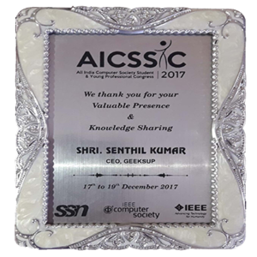](http://geeksup.in/awards/)

[#worldwomenhackathon#ww2k18#asiabookofrecords.](http://geeksup.in/news/)

[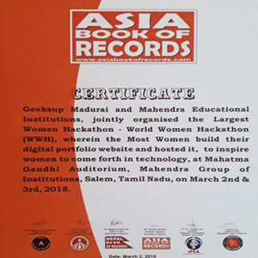](http://geeksup.in/awards/)This occasion was effectively broadcasted by all news channels like puthiyathalaimurai ,news7 and so on. Which make the mindfulness for each lady ,who are viewing the news channels.